**8) Explain in detail the distribution bands in tableau and how to create them with example**

**(With the help of an example create one in tableau)**

In Tableau, distribution bands (sometimes referred to as distribution reference bands or distribution reference lines) are visual elements that help you understand the distribution of data in a view by displaying reference lines or bands at certain percentiles of the data. These bands provide a quick visual representation of how data is spread across different percentiles and can be useful for identifying outliers and understanding the central tendency of the data.

**Creating Distribution Bands in Tableau:**

Here are the steps to create distribution bands in Tableau:

**Step 1: Connect to Your Data and Create a Visualization:**

* Open Tableau and connect to your data source.
* Create the initial visualization, such as a histogram, box plot, or line chart, that represents the distribution you want to analyze.

**Step 2: Add a Reference Line or Reference Band:**

* Right-click on an axis in your visualization.
* Select "Add Reference Line" or "Add Reference Band" from the context menu.

**Step 3: Configure the Reference Line or Band:**

* In the Reference Line or Reference Band dialog box, you can configure the following settings:
* Line/Band Value: Specify the percentile or value for the reference line or band.
* Line/Band Label: Optionally, add a label to the reference line or band.
* Line/Band Options: Choose options such as line type, color, and thickness.
* Scope: Define whether the reference line or band applies to the entire table, pane, or cell.

**Step 4: Add Multiple Bands if Needed:**

* You can add multiple reference lines or bands to represent different percentiles or values in your distribution.

**Step 5: Format and Customize:**

* Format the reference lines or bands to match your visualization's style. You can adjust colors, labels, and other formatting options.

**Example: Adding a Median Line to a Box Plot**

Suppose you have a box plot that shows the distribution of sales across different product categories. You want to add a reference line to represent the median value of sales. Here's how you can do it:

1. **Create a box plot:**

* Drag the "Category" dimension to the Columns shelf.
* Drag the "Sales" measure to the Rows shelf and choose the "Box Plot" chart type.

1. **Add a reference line for the median:**

* Right-click on the vertical axis and select "Add Reference Line."
* In the Reference Line dialog, choose "Median" as the aggregation and customize the appearance as needed.

1. **Click "OK" to apply the reference line.**

This will add a line to your box plot representing the median value of sales for each product category.

**In Tableau:**

**Prerequisites**: Superstore Data-source provided by Tableau, which includes three tables: orders, people, and returns.

**Orders Table**:

Columns: Order ID, Order Date, Ship Date, Ship Mode, Customer Name, Segment, Country/Region, City, State, Province, Category

**People Table**:

Columns: Regional Manager

**Returns Table**:

Columns: Returned

* Select State in columns and Profit in rows and create a bar graph.
* Click on drop-down options of the profit column and click on add reference line.

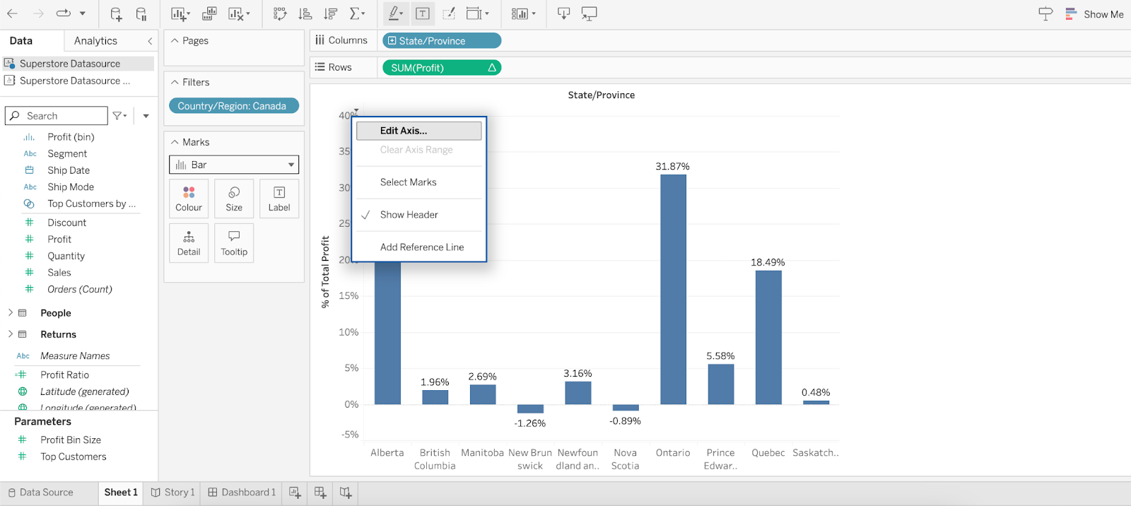

* Select reference for the entire table and set computation to average and close the popup.

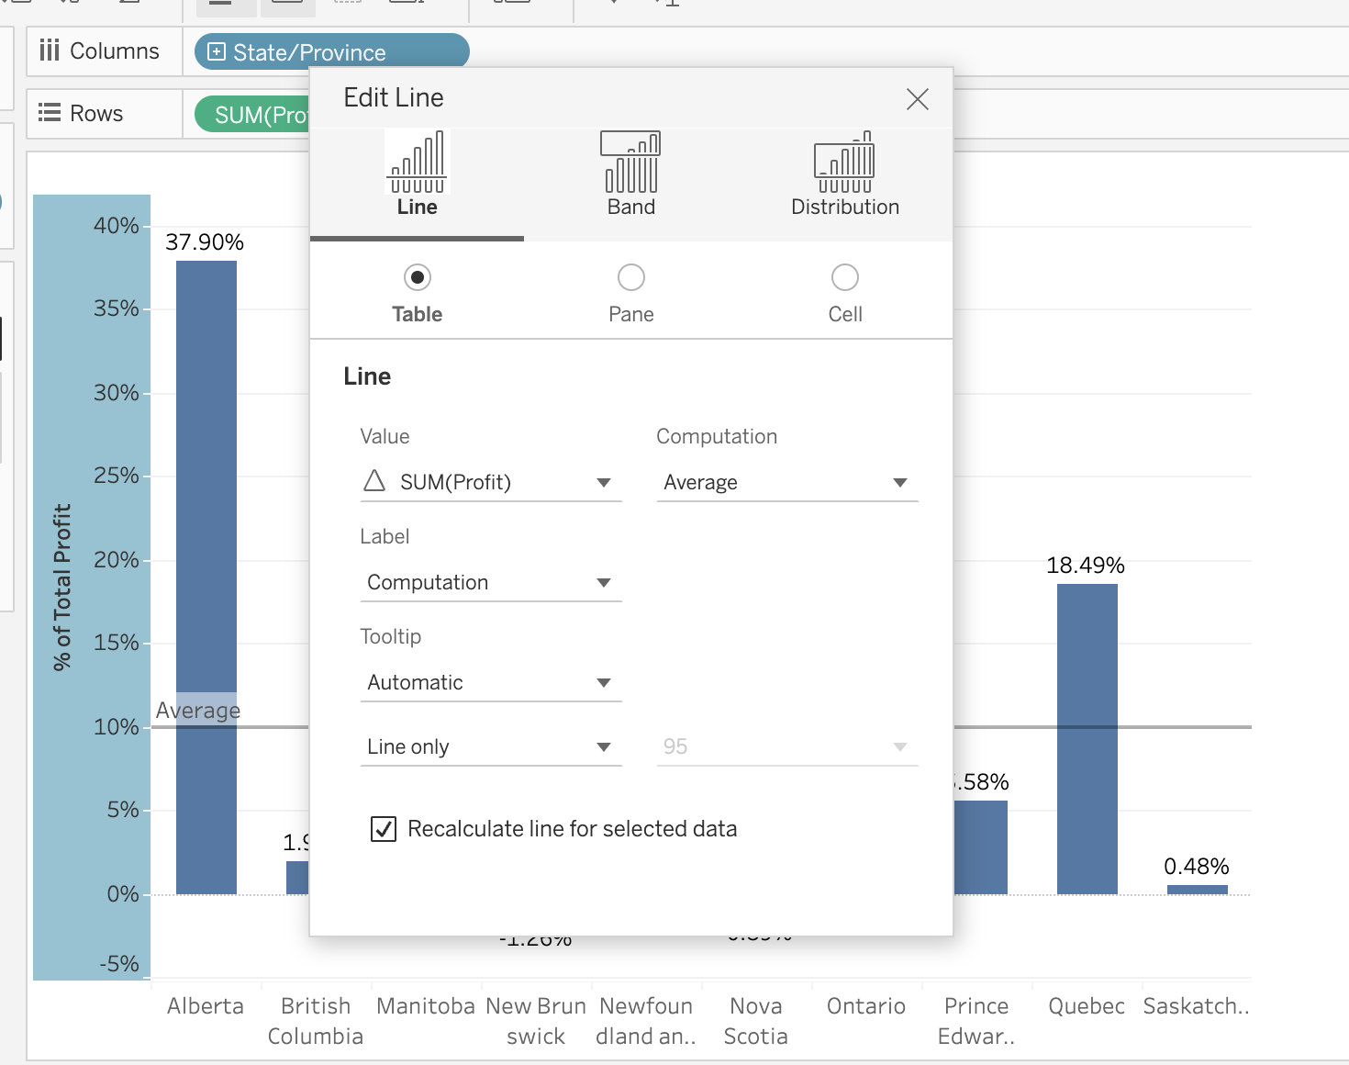

* **Result of reference line:**

